Che-An Wu

Xiaoxiao Qin

Zesheng Xing

Milestone Paper

**BACKGOUND**

Our group decided to create a visualization system that serves the purpose of providing a tactic board for players of the popular PC game, PUBG, in which they can discover valuable insights and trends that can help improve their gaming strategies. We chose to use the dataset below: <https://www.kaggle.com/skihikingkevin/pubg-match-deaths#kill_match_stats_final_1.csv>

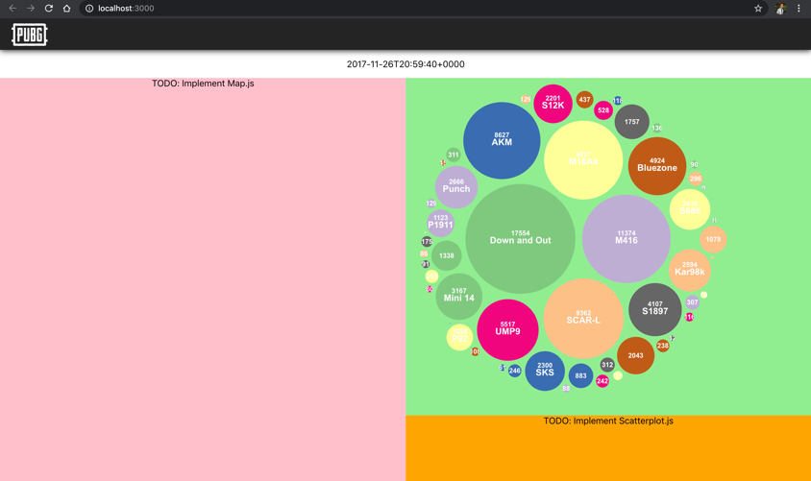

Fig1. PUBG Visualization System (static bubble chart)

To view our react project in action, please go into our project’s directory with a terminal. Then, in the terminal, please do “yarn install” or “npm install” to install all the dependencies. After this, please do “yarn start” or “npm start” to get the project up and running.

**PROGRESS**

To meet the milestone’s requirement, we implemented a bubble chart which can be filtered to show categorical data of the user’s choice. In the screenshot below, we are using the “killed_by” categorical attribute within our dataset, which contains information about the weapons that cause death in the 100k recorded matches. With the current implementation, our component is able to filter the data and render a bubble chart based on a categorical attribute specified by the user.

**INTERACTION & PLAN**

We plan to add a map and a scatterplot matrix that will interact with our bubble chart. The UI/UX of our web app still has a lot of room for improvement, but we want to implement our visualizations and system interactions first. The data filtering for our map component would be both spatial and temporal. By selecting a location on map, users can zoom into the map and see visualization on more granular data. At the same time, our bubble chart and scatterplot matrix will react and display data related to the selected location. In addition, we will also add a time slider UI component that will allow user to see data from different period of times within the game, while also capturing any trend that became obvious as the game continued. The temporal filtering of our map will also result in the other two visualizations updating themselves instantly with the data from the chosen time period.

For the bubble chart, we plan to make it interactive by allowing user to hover over each bubble, in which we will display a tooltip with relevant information. If the user clicks on a bubble, using Ak-47 as example, we will render dots on every location where a death is caused by the weapon within our map component. We may also have the scatterplot display more in-depth data that is relevant to the chosen weapon.

For the scatter matrix plot, the current plan is to visualize the relationship between the various components in the game that the user may be interested in. (for example, deaths caused by AK47 vs M4A1, or player survival time vs initial placement in game). The scatterplot matrix plot will interact with the filtering that is used on the map and bubble chart. In addition, when the user uses our time slider to filter temporally, the scatterplox matrix will interact by showing the data relevant to the chosen time period.